# **Decode: A STEM Adventure Kit**

Welcome to a STEM adventure! This was created by the SWARM Robotics team to encourage others to get interested in Science, Technology, Engineering, and Mathematics. It is inspired by the theme of our First Tech Challenge competition this year: Decode! This kit takes at least 2 people: one person to set up the STEM scavenger hunt, and the other person to complete it. The hunt can also be done by a small group of people working together. Below are the setup instructions. If you are the person doing the hunt, don’t read them - they contain spoilers! If you’d like to learn more about STEAM opportunities in the Saline schools, check out this page: <https://www.salineschools.org/extracurriculars/clubs--activities/steam/>

**Setup Instructions**

Make sure that your adventurer’s kit is complete with their exploration tools: a compass, a UV spy pen, a fresnel lens, a red light filter, and a decoder key.

[**UV Light marker link**](https://www.amazon.com/STENDA-Invisible-Blacklight-Christmas-Thanksgiving/dp/B08XW8L2NX/ref=sr_1_5?crid=2N8JKCR6FZVS4&dib=eyJ2IjoiMSJ9.k8qlgxXoDGJdnK6WSbHwe8OLJw6oEU2dlzZjPdbhvIkgUypnpdYetnkvxr1AYrkFnPcyAwyGffxcFW89m55jyhoZpTzU6Q4VrawoK6gmPELrc3Uxpdrrsb5fpFAAPN9O_WaN_V36v-88wRCLdpwoxmkfk6HTrjOONA7p0xLaD9XNrId6QlVOgDv8yDdrzYOE1us8hsruiAi0wKgMJpEtuJdeKy1k_O26WNrEWVSlSeeNUZbo8FWPvLQn8iEHWSOlqsoKh5M4D7NwqtBrJjW1dxGrTRZ_Xat33QuS4HbDL9o.M2XaNQnyvS43txCx_IwxEoMppsLMJVIlvtjC5g04cq8&dib_tag=se&keywords=invisible+ink+pen&qid=1762200667&sprefix=invisible+ink+pen%2Caps%2C161&sr=8-5)

**Print out camel image or draw it (optional)**

[**Compass**](https://www.amazon.com/Compass-Hiking-Survival-Small-Pocket/dp/B0B2LQTT1P/ref=sr_1_1_sspa?crid=2DP7GX2IIQMAR&dib=eyJ2IjoiMSJ9.UjASFfa7bm4XAa3xcrUjTm2mVetD4ycX7vMNRfj_UrohEBwmBdxpvYvhOBUQ3bHmcQY5ns9k8pvB2QzCGwGb33v8v_hG8zXTGGNDBY4-jH9gxYavgyMQKkz-CE2-Y9U8xC8_Zhv2WOwzX695joZX_LToJX4F-nFRAlbmdrfB-hky0_wsl2XWZ_cdsLBwUbmp2rKjXS6Nbyte6gbRRh6E4cXacEBr6Lg2B9Z5UTkowlCp4JsnIv3N3Ojl9DeEuHgEZxbMZrA3q3xj-e4McM7QQBX4OivFf8YUOTDpmxblWSQ.HXnjmmJAMkpbcjezVxii8djMC9ZbTz6AP8zWxTm5KhY&dib_tag=se&keywords=mini%2Bcompass&qid=1762200889&sprefix=mini%2Bcompas%2Caps%2C175&sr=8-1-spons&sp_csd=d2lkZ2V0TmFtZT1zcF9hdGY&th=1)

[**Fresnel Lens**](https://www.amazon.com/Hestya-Fresnel-Magnifier-Reading-Starter/dp/B07CPSXPP4/ref=sr_1_3_sspa?crid=19AK6722CRC1B&dib=eyJ2IjoiMSJ9.U-EpEjbmUNtF3W3WEi7R16uyHCIw5_4GK7pKN67kB-d9hSqwRu0Hhvx8ib6z3n6MDfqqIlmXKTwmeK0SXlNkBDgRs8IYffC4assyp9v4N2S5NRr5jkJe6Annmku2I37m91CfXDO8-WOeAB-oJeGYNvGIs8XKx1de84ZXnkelI7jONySGhXvC_0p9j_Jmd4kz1WVE93XEGlfgYDIIRNlTDh7M2AMy94X7mKxyVDVtteMYgqb7OaXVb1lQFFGGd__FSeooALAWeCuAdUzL8waF_0JwiOJ6EA4zhvGC-ezk8QY.zv-MKzT1t0C6rU7eUoU514WBrwY90WauwfTLulGxzyQ&dib_tag=se&keywords=fresnel%2Blense&qid=1762200917&sprefix=fresnel%2Blens%2Caps%2C148&sr=8-3-spons&sp_csd=d2lkZ2V0TmFtZT1zcF9hdGY&th=1)

[**Red Light Filter**](https://www.amazon.com/Transparency-Overlays-Correction-Lighting-Decorations/dp/B07ZG91B85/ref=sr_1_1_sspa?crid=HQRT7SLUMR2R&dib=eyJ2IjoiMSJ9.5BdQOtCE_zmwVfnAFigSKKJe7aveIawBMSahJfF3ciJ3sUPXjCVd-Mlug9p3CGDsO5vzRQ5h1dIOFYZyPDw_CUtYWbRQUfTdLyY5aZViMGP8IxGIwD6hpTxNGAH40oHU6FuVgltcjmX39B6QOFLX1q9iK5pB1dqWB2qnYpVSx85yYInVk_on8T2fV6qgSZA-LCr-lOxQQoSyHKlvAfKwUAJS4HhRpE2sCqXjY-erOEk.M0gv-6c_tCtgnDI6o0cNmb80z6sLqd-jTOmIQNwyOX0&dib_tag=se&keywords=red%2Blight%2Bfilter&qid=1762200945&sprefix=red%2Blight%2Bfilte%2Caps%2C145&sr=8-1-spons&sp_csd=d2lkZ2V0TmFtZT1zcF9hdGY&th=1)

Choose a different room or location for each of the puzzles. Puzzle 1 needs to be in a space with at least 12’x12’ square of open space. Puzzles can be hidden in the same room, with one being out in the open and another out of sight. (Under a pillow or in something, for example.)

The supplies for each puzzle are in designated envelopes. There may also be a packet of 3D printed camels. They are prizes for each puzzle. You can put the camels in the solution envelope or under the solution paper for each puzzle.

**Puzzle 1: Compass Navigation**

Choose a place for Puzzle 1 with at least 12’x12’ of space to work with. Stand in the center of the 12’x12’ space and place “Adventure starts here” paper on the ground. This is your starting point!

Find the 4 envelopes labeled P1 (P1a, P1b, P1c, and P1d.) Get out your mini-compass from the kit. Standing on the starting point, hold the compass **flat** at waist height and look at the compass. Notice the “cardinal directions” on the compass: N, S, E, and W. (North, south, east and west.) Take envelope P1B, walk 5 steps in the direction of North. Place the envelope on the floor. This envelope has the correct clues to the next puzzle in it. Return to the start. Place the remaining envelopes (P1a, P1c, and P1d) 5 steps away from the start in the other cardinal directions. For example, put P1a five steps to the East, P1c five steps to the South, and P1d five steps to the West. They each have “scorpions” in them.

Pull out the paper that says, “Your next puzzle can be found _________________” and write the location for the next puzzle. Place that paper in the P2 Envelope (North). Put the camel in the envelope. Puzzle 1 is now complete. Go to the location for Puzzle 2.

**Puzzle 2**

Get out the UV Light marker from the Adventure Tool Kit. Get out another paper that says, “Your next puzzle can be found ________________” and write the location for Puzzle 3 using the UV light marker. You won’t be able to see what you write - your clue can only be read by shining the UV light on what you wrote. Place the clue and a camel in Envelope P2 and set it out in the open where it can be seen. Put the marker/light back in the Adventure Tool Kit. Puzzle 2 is now complete. Go to the location for Puzzle 3.

**Puzzle 3**

Set out the picture of the Pyramids with the code on the top. Next to it, set out the papers that have big numbers on them (20, 12, and 5). The middle pyramid has a teeny tiny math problem along the bottom edge that the adventurer can read with the fresnel lens in the tool kit. The code tells the adventurer to solve the math problem to figure out what paper to flip over for the next clue.

Choose the location for the next puzzle, Puzzle 4. Write that location on the back of the “answer” sheet, the one that says “5”. (“5” is the answer to the math problem.) Put the camel under the paper. Puzzle 3 is complete. Go to the room you chose for Puzzle 4.

**Puzzle 4**

Find the 3 envelopes labeled P4A, P4B, and P4C. Place them where they are visible. Place this instruction sheet out near the 3 envelopes:

“You’ve entered a room where something is creating magnetic interference. It is an artifact! Use the compass to determine which envelope is creating the magnetic interference. The clue is in this envelope.”

Write the location of the final puzzle on the paper that says “Your next puzzle can be found ____________________” . Put that paper into envelope P4C. This envelope has a tiny magnet in it, which can be detected by using the compass. The compass needle will swing wildly when it passes near the magnet. Put the camel in the envelope. Puzzle 4 is complete.

**Puzzle 5**

Find the “motif” paper with blue and red shapes on them and place that paper in the place that you wrote down in Puzzle 4.Find the papers that have shapes on them and put them near the Motif. The adventurer will use the Red filter to decode the motif and flip over the paper with the correct motif on it. If they flip over the wrong paper they will get “stung” by a scorpion. The correct “motif” is the paper with the triangle,square and circle on it, in that order. Put the camel under the paper.

**The Science behind the Adventure:**

**Puzzle 1:** 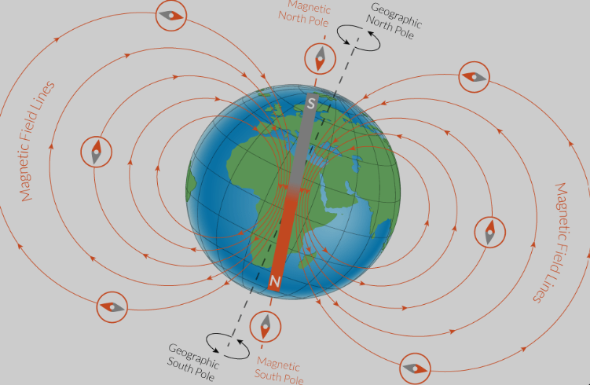

Compasses use a magnetized pointer that aligns with the earth’s magnetic fields. The earth has magnetic fields because of convection currents in earth’s molten iron core. The red pointer of a compass will always point toward magnetic north unless it is picking up interference from another magnetic field, or if the earth’s magnetic field is being blocked by metal (like in a car.)

**Puzzle 2:** 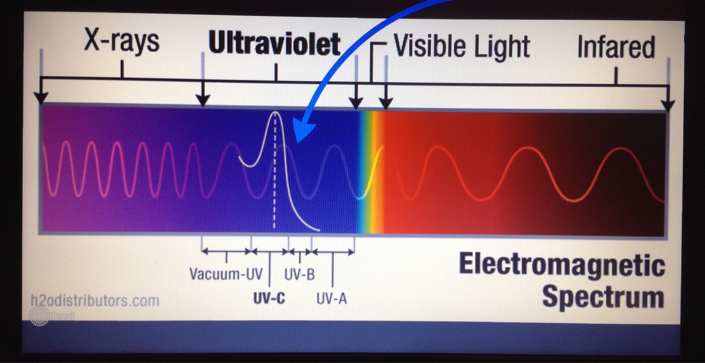

Light travels to our eye in waves, and the length of the wave determines the color. The ink in the spy pens contain fluorescent chemicals which are invisible to the naked eye. They are outside of the visible wavelength but are visible when you shine a uv light on them.

**Puzzle 3:**

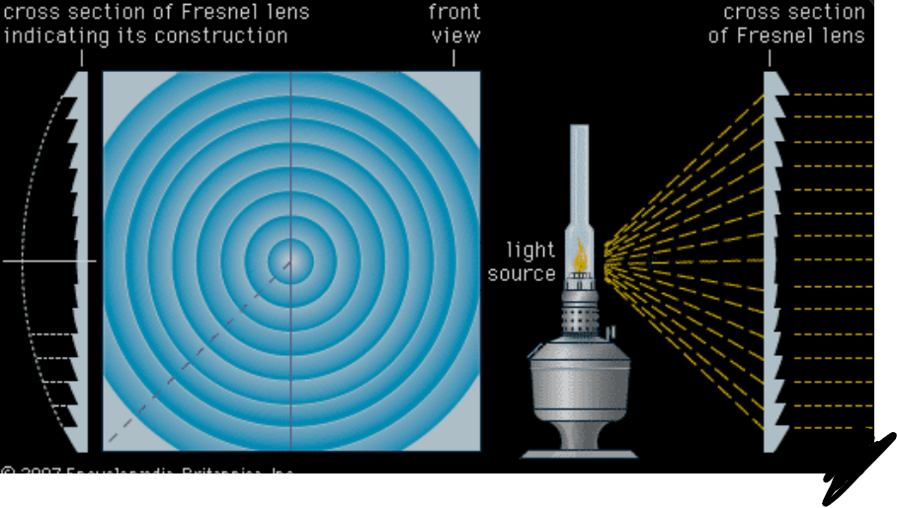

A Fresnel lens is a type of lens that is a composite compact lens and shrinks the amount of material required compared to a conventional magnifying lens by separating the lens into a set of concentric annular sections. The lens was invented by the French physicist Augustin-Jean Fresnel from (1788–1827) for use in lighthouses.

**Puzzle 4**:

The magnetized pointer on a compass is sensitive to all magnetic fields, not just the earth’s! If a compass is near something that generates a magnetic field, it will cause the needle to swing around to align with the local magnetic field, not the earth’s magnetic field.

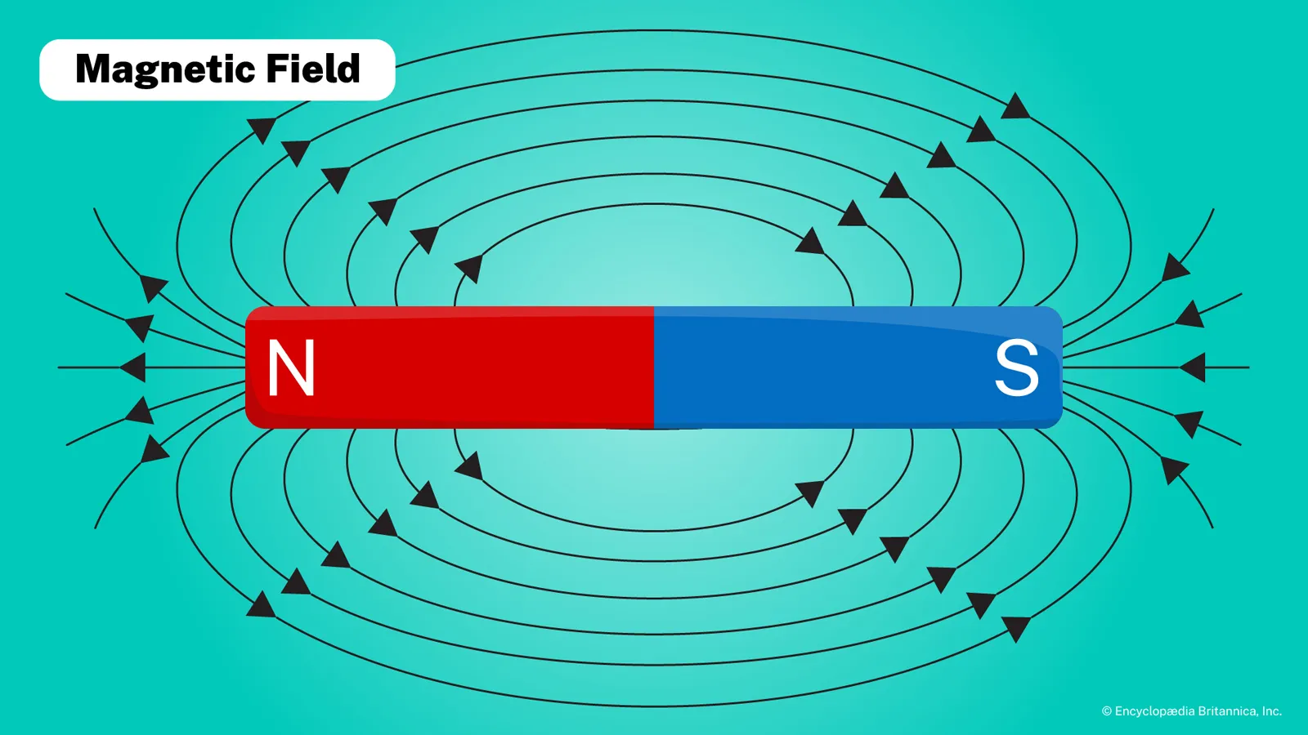

**Puzzle 5:**

Visible light travels in waves, and the size of those waves determines the color of the light and what we see. When light passes through a colored filter, the filter blocks certain wavelengths and lets other wavelengths through.

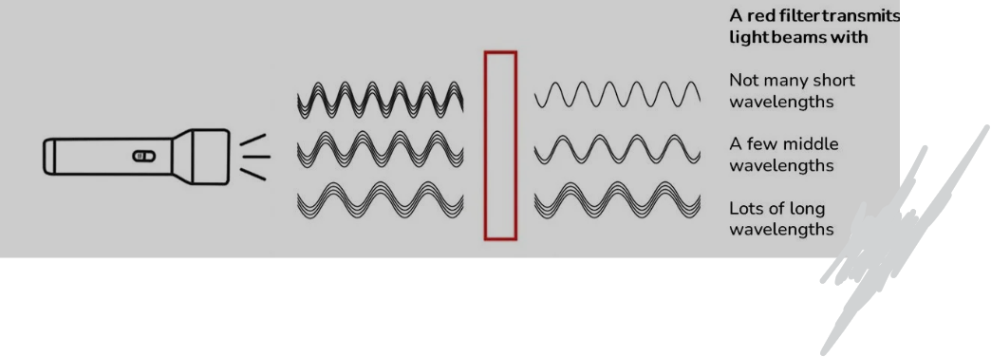 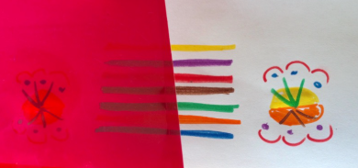

**Questions or feedback? Email the team,** [**ftcrobotics15555@salineschools.org**](mailto:ftcrobotics15555@salineschools.org)